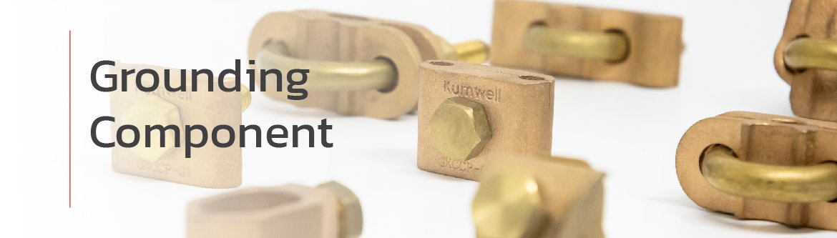
Grounding Components Importance
There are several main objectives for well-designed grounding systems: personal safety, equipment protection, signal reference quality, faults & surges return path, and static dissipation. Also, connections in the ground network are subjected to severe corrosion, high mechanical stress due to electromagnetic force, and thermal heating due to high current magnitude during fault conditions. Grounding components are crucial grounding support to meet the well-designed goals, which are maintaining a low contact resistance under adverse conditions for the expected lifetime of the groundings systems.

Ground Clamps
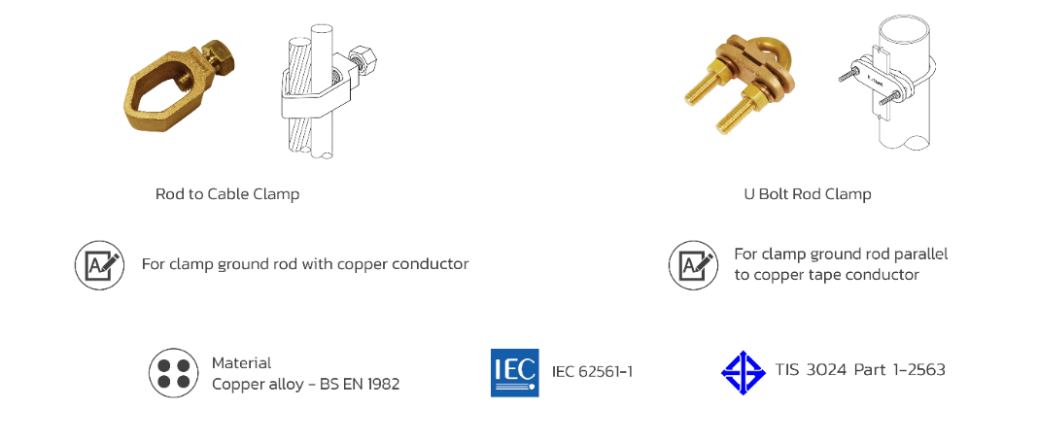
Earth Points


Equipotential Ground Bars
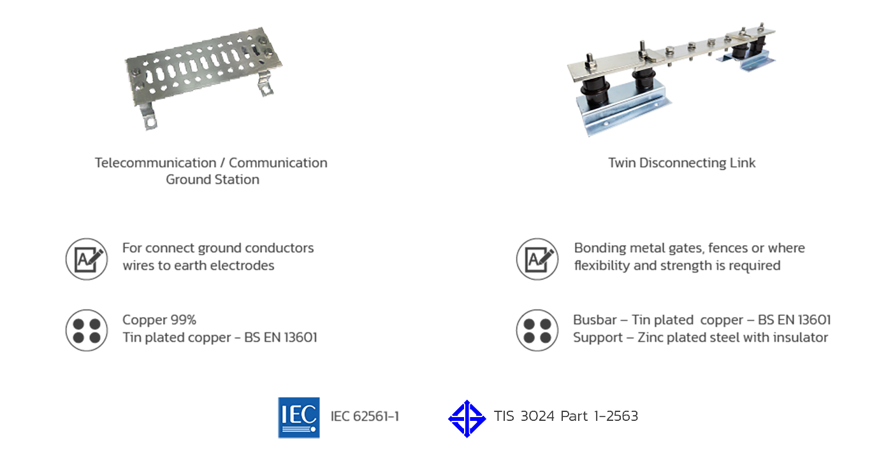

Ground Plates

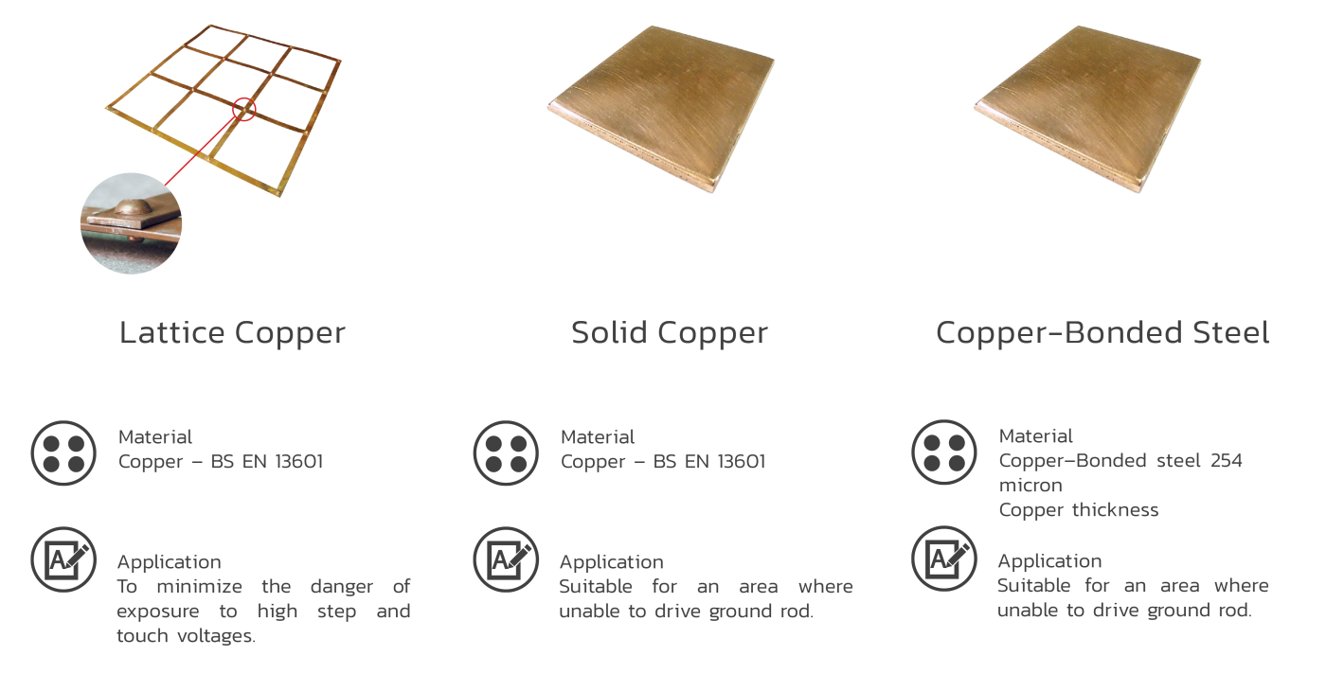

Concrete Inspection Pits

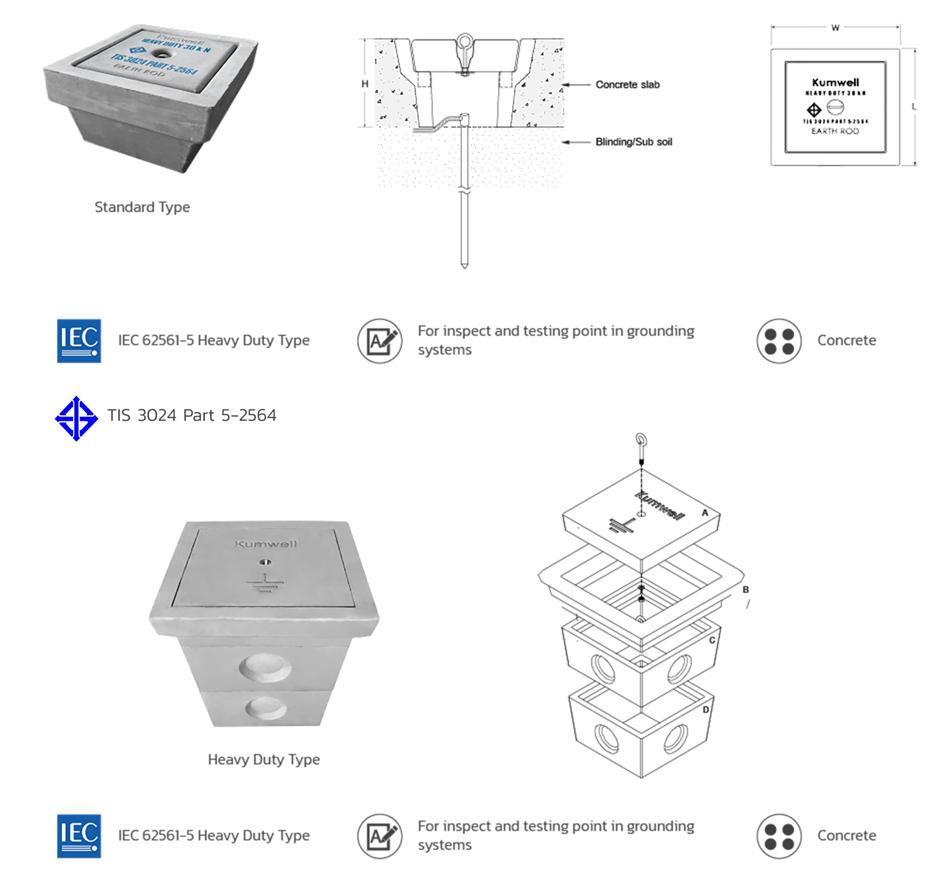

C-crimp Clamps
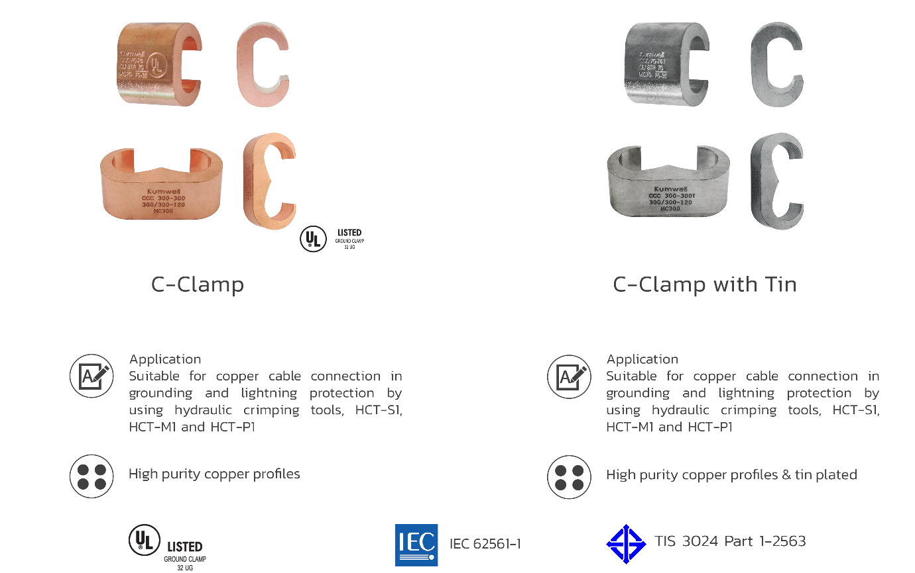

Copper Lugs
